
ZANZIBAR AGRICULTURAL RESEARCH INSTITUTE
(ZARI)

RESEARCH TITLE

MENAI BAY BIODIVERSITY FAUNA AND FLORA RESOURCES INVENTORY IN MENAI BAY ZANZIBAR.

2023/2024
Address: Kizimbani-Zanzibar
Email: Info@zarismz.go.tz

Authors: Wahida M. Ali; Dr. Masoud Salim Said; Seif Hamza Mohammed; Mossi Seif Khatib; Maulid Khalifa Abdalla

ABSTRACT
The world is home to millions of flora and fauna species, each adapted to different environments including tropical, temperate, polar, terrestrial, freshwater or marine, high or low altitude, dry, wet or a mixture and intermediate of foresaid conditions. The Earth's biodiversity contributes to the productivity of natural and agricultural systems. Tanzania has a rich and diverse spectrum of animals and plants including a wide variety of endemic species and subspecies. Menai Bay is among most common area with a wide range of fauna and flora diversity, direct depends on the natural (environmental) and anthropogenic conditions. Therefore, this research intended to identify and describe fauna and flora species in Menai Bay with their affecting environmental and anthropogenic conditions. The research was conducted in Kikungwi ,Unguja Ukuu, Uzi and Muungoni villages within the Menai Bay area located in the South West Region of Unguja Island. Data for this research were collected through observational walk along coastal line capturing information within 50m from the seashore towards inland as well as 50m towards sea followed by interviews to the prominent personnel in each of villages. This research has found that Menai Bay and its surroundings is likely maintain its intactness on fauna and flora resources and can be used as among the hub for exploration and its contribution on knowledge, wildlife, culture, tourism, for social and economic gain of individuals, groups, family as well as the country as whole. This research on inventory of fauna and flora resources of Menai Bay concluded that fauna and flora resources are relatively decreasing in diversity and number of species specifically Jeta might enter on endangered stage.

1.0 INTRODUCTION
  - Background Information
The world is home to millions of flora and fauna species, each adapted to different environments including tropical, temperate, polar, terrestrial, freshwater or marine, high or low altitude, dry, wet or a mixture and intermediate of foresaid conditions. But the density of biodiversity varies a lot across the world’s continents. However, scientists have estimated that the number of species of plants and animals on earth could vary from
1.5 to 20 billion. Thus the majority of species are yet to be discovered. Most of the world’s bio-rich nations are in the Southern part of the earth. Tanzania has a rich and diverse spectrum of animals and plants including a wide variety of endemic species and subspecies. The diversity and degree of endemism in Tanzania is fairly high (Wildlife Division, 1998). For example, of the 18 primate species, 5 are endemic, there are 30 antelope species and 2 are endemic, and 60 species of reptiles are endemic out of the 227 species present in the country. There are also many other species of fish, birds, amphibians and plants unique to our country. Furthermore, there are over 600 endemic plant species in Tanzania most of them in the eastern arc forests/coastal forests. There are other species still unknown to science and are awaiting discovery particularly in the eastern arc mountains, Zanzibar and Pemba islands.

Within the coastal forests biodiversity hotspots in East Africa, the importance of Zanzibar and Pemba islands has been recognized. Zanzibar has been separated from the mainland Tanzania for about 10,000 - 15,000 years. During this time species have been evolving separately from their mainland counterparts. This has resulted into the presence of a number of new species and sub species of both flora and fauna.

Importance of Biodiversity to Humanity
The Earth's biodiversity contributes to the productivity of natural and agricultural systems. Insects, bats, birds, and other animals serve as pollinators. Parasites and predators can act as natural pest controls. Various organisms are responsible for recycling organic materials and maintaining the productivity of soil. Genetic diversity is also important in

terms of evolution. The loss of individuals, populations, and species decreases the variety of genes (genetic diversity) the material needed for species and populations to adapt to changing conditions or for new species to be involved. In recent years knowledge of biodiversity has increased, as has the realization that something must be done to counteract the loss of species, populations, and ecosystems. There is still much to be learned about biodiversity and its relationship to the functioning of our world. Ecologists conduct research to better understand biodiversity, quantify its loss, and develop strategies for conserving and using it. Much is still unknown as to what species exist, where they occur, and the relationships between them. By inventorying and monitoring biodiversity, ecologists’ study species abundance, functions, interactions, and importance to maintaining or enhancing the quality of human life.

    - The Role of Human on Biodiversity
Maintaining a wide diversity of species in each ecosystem is necessary to preserve the web of life that sustains all living things. In his book "The Diversity of Life," Wilson (1992) said, "It reckless to suppose that biodiversity can be diminished indefinitely without threatening humanity itself." Human activity has caused an alarming number of species to become extinct. When a large number of species perform various functions, an ecosystem is more stable. The fewer species there are filling certain niches, the more unstable the environment becomes. Humans have always depended on the Earth's biodiversity for food, shelter, and health. Biodiversity also supplies indirect services to humans, which include drinkable water, clean air, and fertile soils. The loss of populations, species, or groups of species from an ecosystem can upset its normal function and disrupt these ecological services.

  - The role of Local Social Economy on the Biodiversity
Zanzibar has approximately 20, 000 hectare of mangrove forest and most of them cover along the shallow water coast (FAO, 2005). About 45% of the total populations of Zanzibar lives along the coast, majority of them are involved in the extraction of natural resources and fishing for their

livelihood (Kombo, 2010). Like many other poor countries, Zanzibar could not escape the fact of her people having a heavy direct dependence on natural resources (Silimaet al, 2008). The estimation indicated that, 67% of Zanzibar’s fauna left without management plans and is highly degraded (Silimaet al, 2008).

Climate
Menai Bay biodiversity enjoys a tropical climate that is largely dominated by the monsoons which bring the short and the long rains, like a climate (tropical climate) of other areas in Zanzibar islands (Makame, 2006). The climate is moderate tropical and warm all year round with a minimal temperature variation range from 25º to 30º C, and the humidity especially during the rainy seasons (Makame, 2006). The total annual rainfall average is about 1629 mm/year (Makame, 2006). There are two distinct rainy seasons; from January to March this is hot, dry and sunny period with little rainfall (summer). Between March to May or June, this is rainy season; the rain is almost always in the form of strong but quick showers, as it is produced by the monsoons, and hence stormy (autumn). From July to October this is warm, sunny with cold winds (winter). And from October to December, this is short rains in November hot and sunny (spring) (Makame, 2006). The average water depth in the Bay area is about 10 m during high tide (Ruitenbeek, et-al, 2005).

Problem Statement
The problem statement was based on the fact that, Menai Bay has wide variety of fauna and flora species diversity. However, some species were either not been identified yet or varnishing with time. The distribution of fauna and flora diversity in Menai Bay direct depends on the environmental conditions. Therefore, this research has observed environmental conditions diversifying facing fauna and flora species in Menai Bay. Moreover, the bay has experienced dramatic change in the uses of resources. Normally the bay offers key habitats for high diversity of indigenous, endemic, rare and endangered species. However, there is habitat loss and degradation of species diversity. Therefore, this research

phase intended to identify and describe fauna and flora species in Menai Bay.

Objectives General Objective
The general objective of this study is to assess richness and relative abundance of flora and fauna on coastal line ecosystem of Menai Bay.

Specific Objectives
The study will be carried out on the four specific objectives.
    - To identify flora and fauna species diversity in Menai bay.
    - To find out flora and fauna species dominance in Menai bay.
    - To determine important of ecological (natural and anthropogenic) factors associated with flora and fauna species diversity.

Significance of the study
Menai Bay is rich biodiversity with fauna and flora species including rare, endemic and endangered species, (Finke, J. 2006) which are reptiles, amphibians, and arthropods insects, crustaceas and myriapods which they exchange matter and energy with their surrounding and every species has play its important role in the ecosystem (Malimbwi, 2004), Kupnick (2001).
More over Menai Bay consists of terrestrial and marine flora and fauna in the archipelago of Zanzibar, an autonomous region of Tanzania. Its faunal species are mostly small animals, birds, and butterflies. Maintaining a wide diversity of species in each ecosystem is necessary to preserve the web of life that can be diminished indefinitely without threatening humanity itself. Human activity has caused an alarming number of species to become extinct.
Fauna in Menai bay differ with large variety of species. Along the study areas will identified with occupy for rare species, endangered species, and endemic species. We can use a variety of methods to identified populations of fauna diversity. It is needed to consider the ecosystem terrain, climate and time. It would be ideal to see and count each individual animal in a population, this is called a census. Animals have

tendency to move from place to place, they hide, they hibernate and they are often camouflage and difficult to see in their environment. Menai bay has a rich and diverse spectrum of animals and plants including a wide variety of endemic species. The diversity and degree of endemism is fairly highly. Maintaining a wide diversity of species in each ecosystem is necessary to preserve the web of life that sustains all living things. The diversity of life (Wilson 1992) said It is reckless to suppose that biodiversity can be diminished indefinitely without threatening humanity itself. Human activity has caused an alarming number of species to become extinct.
The presented findings in the current work represent information contributing to the existing literatures of fauna diversity available for students, researchers and decision makers, be aware of anthropogenic illegal activities conducted in natural resources. The findings with contribute to available information on the fauna species diversity of Menai Bay Forest Reserve and the associated threats of both legal and illegal activities, hence helping in the implementation of conservation laws, by laws for the persistence of plant taxa. It has been known that list of plant species always contribute to the fauna literatures, while the revealed anthropogenic activities stimulate the conservation strategies for the study area (Gall et al., 2002). Malimbwi (2010) postulated that fauna species diversity and is only known through systematic assessment of the composition abundance and diversity; if at all the human beings need to come up with a vegetation management plan. The results presented in the current report is an attempt to close an existing gap in terms of knowledge on species diversity and anthropogenic activities conducted at an alarming rate in the conserved of Menai bay.

The results from this study will make contribution on understanding the current situation for fauna species in the community and habitat sites as well as the threats they face. Also this study will provide a better understanding of the current situation of diversity and density of fauna species and also based on such information, conservation of species diversity, ecological process will be possible with proper management of the ecosystem and sustainable utilization of resources.

2.0 MATERIAL AND METHOD
  - Study area
The study was conducted in Menai Bay. Menai Bay located in the South West Region of Unguja, the main Island of Zanzibar. It covers an area of about 470 square kilometer and is the largest conservation area in Zanzibar, Department of Fisheries and Marine Resources (DFMR, 2011). The bay has six islets and it’s a coast line of 61 km (DFMR, 2011). It lies on latitudes 6°23′0″S and longitudes 39°22′00″E (Ruitenbeek, et-al, 2005). Also the bay has altitude as approximately 1m above the sea level (Ruitenbeek, et-al, 2005).

Scope of the Study
The scope of this research study was limited to coastal areas of Menai Bay Conservation Area (MBCA). However, for this phase the research scope was limited to about 2km along coastal line of each of the four communities which were: Kikungwi ,UngujaUkuu, Uzi and Muungoni Figure 1.

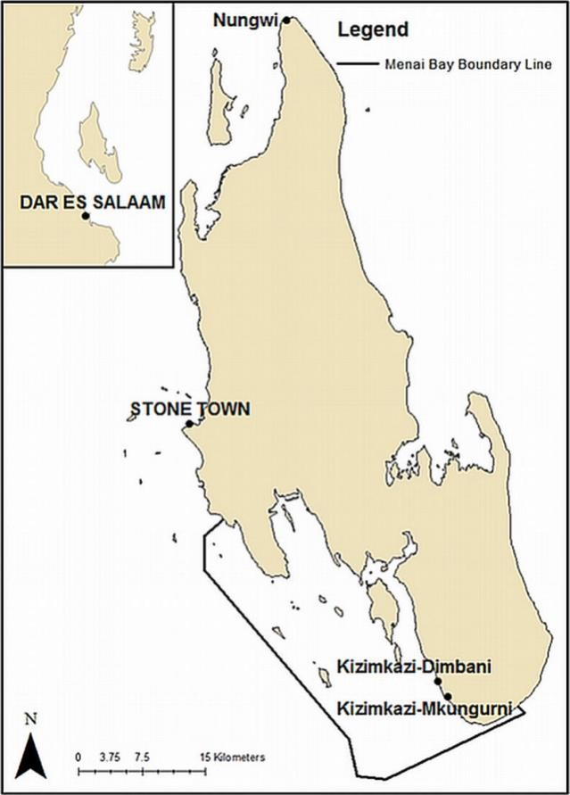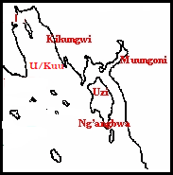

Figure 1: Map of Unguja Island, showing the location of Menai bay and Study Areas.

  - Data Collection
For a broader generalization, study on biodiversity required a large amount of empirical data from study area. However, the data for this research were collected through observational walk along the coastal line of the research area followed by interview. The research team selected prominent person within the villages of Unguja Ukuu (Kaepwani and

Tindini), Kikungwi, Uzi Ng’ambwa and Muungoni and Kikungwi. Table 1 shows the date and villages of the research walks done by the team together with the selected persons from the above mentioned villages. The walk was done during low tides. Along the Menai Bay seashore the research team captured the variety of fauna and flora, human activities and related environmental issues. Flora and fauna inventory was done as the research team paced along the coastal line capturing information within 50m from the seashore towards inland as well as 50m towards sea within the said study area. The questionnaire, Annex I was used to capture the social economic information and general estimation of the identified species during the walk. The interview with the prominent persons was done after the observation walk.

Table 1: Geographical location of study walk, 2023

DATE | VILLAGE | EASTERN | NORTHERN | ENVIRONMENT
06/07/2023 | UngujaUkuu | 549600.9 | 9303675.7 | Bushy area and mangrove, sandy
10/07/2023 | Kikungwi | 54634.26 | 393256.56 | Open and bushy, coral seashore
11/07/2020 | Uzi | 543375.46 | 9296558.27 | Coconut plantation, open and bushy
17/07/2023 | Muungoni | 545623.01 | 394124.90 | Bushy area, mangrove, coral seashore

3.0 RESULTS
The captured information during the study walk is presented in Table 2.

Table 2: Fauna and Flora Resources captured during study walk in Menai Bay, 2023
 | SPECIES | KKN |  | MNN |  |  | UNU |  |  | UZI |  |  | CATEGORY
 | TYPE | Arthropods
# | Common name | SCR | I/  D | SCR |  | I/  D | SCR |  | I/  D | SCR |  | I/  D | NM  L | RA  RE | EN  G
1 | Butterfly | 180 | D | 900 |  | I | 1000 |  | I | 1200 |  | I | N
2 | Ants | 2000 | I | 800 |  | I | 400 |  | I | 950 |  | I | N
3 | Grasshopper | 10000 | I | 7000 |  | I | 9000 |  | I | 10600 |  | I | N
4 | Snail | 1000 | D | 60 |  | D | 200 |  | D | 800 |  | D |  | R
5 | Mouse | 200 | D | 700 |  | I | 350 |  | I | 800 |  | I | N
6 | Termites | 1650 | I | 2200 |  | I | 3200 |  | I | 6000 |  | I | N
7 | larva | 11200 | I | 1500 |  | I | 1000 |  | I | 10000 |  | I | N
8 | Crabs | 600 | D | 200 |  | D | 800 |  | D | 900 |  | I |  | R
9 | Oyster | 10000 | D | 1200 |  | D | 200 |  | D | 13000 |  | I |  | R
10 | Octopus | 1501 | D | 800 |  | D | 300 |  | D | 1400 |  | I |  | R
11 | Bees | 20000 | D | 1500  0 |  | I | 1300 |  | I | 22000 |  | I | N
12 | Uvi | 407 | D | 201 |  | D | 800 |  | I | 600 |  | I | N
13 | Majimoto | 6510 | I | 8000 |  | D | 100 |  | D | 900 |  | I | N
14 | Siafu | 4000 | D | 2000 |  | D | 301 |  | D | 5000 |  | I |  | R
15 | Spider | 200 | D | 800 |  | D | 150 |  | D | 900 |  | I | N
16 | Duduvule | 80 | D | 200 |  | D | 70 |  | D | 300 |  | I |  |  | E
17 | Jongoo la  pwani | 800 | D | 1200 |  | D | 1300 |  | D | 1500 |  | I |  | R
18 | Lobster | 200 | D | 500 |  | D | 300 |  | D | 400 |  | D |  | R
19 | Jeta | - | D | - |  | D | - |  | D | 100 |  | I |  |  | E
 | Category | Reptile
1 | Snake | 50 | D | 20 | D |  | 26 | D |  | 60 | I |  | N
2 | Lizard | 200 | I | 700 | I |  | 500 | I |  | 800 | I |  | N
3 | Python | 6 | D | 12 | D |  | 23 | D |  | 35 | I |  | N
4 | Chamelon | 50 | D | 80 | D |  | 30 | D |  | 100 | I |  |  | R
5 | Kiumambuzi | 45 | D | 31 | D |  | 50 | D |  | 30 | D |  | N
6 | Guruguru | 70 | D | 85 | D |  | 40 | D |  | 60 | D |  | N
7 | Kenge | 50 | D | - | D |  | 20 | D |  | - | D |  |  | R
 | Category | Birds
1 | Chozi | 07 | D | 13 | D |  | 52 | I |  | 60 | I |  |  | R

2 | Tiva | - | D | 06 | D | 10 | D | 15 | I |  | R
3 | Mnana | 10 | D | 20 | D | - | D | 30 | I |  |  | E
4 | Vijumbamshale | - | D | - | D | 10 | D | 50 | I |  | R
5 | Yangeyange | 12 | D | 50 | D | 20 | D | 20 | D |  | R
6 | Kuruwiji | 18 | D | 32 | D | 42 | D | 55 | I |  | R
7 | Fufu | - | D | - | D | 15 | D | 30 | D |  |  | E
8 | Msese | 30 | D | 45 | D | 08 | D | 68 | I |  | R
9 | Golegole | 48 | I | 81 | D | 20 | D | 100 | I |  | R
10 | Bundi | 05 | D | 02 | D | 07 | D | 12 | I |  |  | E
11 | Chomehizi | 15 | D | 09 | D | - | D | - | D |  |  | E
12 | Chechea | - | D | 02 | D | 06 | D | 15 | I |  |  | E
Table Continues
SPECIES |  | KKN |  |  | MNN |  |  |  | UNU |  |  |  | UZI |  |  |  | CATEGORY
TYPE |  |  | Mammals
# | Common name | SCR | I/D |  | SCR |  | I/D |  | SCR |  | I/D |  | SCR |  | I/D |  | NML | RAR  E | EN  G
1 | Antelope (Nunga) | 03 | D |  | 06 |  | D |  | 05 |  | D |  | - |  | D |  |  |  | E
2 | Monkey | 40 | D |  | 21 |  | D |  | 30 |  | D |  | 100 |  | I |  |  | R
3 | Chindi | 900 | I |  | 300 |  | I |  | 200 |  | I |  | 700 |  | I |  | N
4 | Cheche | 200 | I |  | 150 |  | I |  | 80 |  | D |  | 330 |  | I |  | N
5 | Panyabuku | 60 | D |  | 31 |  | D |  | 52 |  | D |  | 25 |  | I |  |  | R
6 | Ngombo | 110 | I |  | 51 |  | D |  | 20 |  | D |  | 130 |  | I |  |  |  | E
7 | Ngawa | 50 | D |  | - |  | D |  | 10 |  | D |  | 60 |  | I |  |  |  | E
8 | Fungo | - | D |  | 72 |  | D |  | 21 |  | D |  | 80 |  | I |  |  |  | E
9 | Komba | 500 | I |  | 105 |  | D |  | 80 |  | D |  | 600 |  | I |  | N
 | Category |  | Amphibians
1 | Toads | 80 | D | 42 |  | D |  | 65 |  | D |  | 50 |  | D |  |  |  | R
 | Category |  | Plants
1 | Mikururu | 600 | D | - |  | D |  | 300 |  | D |  | 800 |  | G |  |  |  | R
2 | Minazi | 300 | D | 800 |  | D |  | 800 |  | D |  | 900 |  | G |  | N
3 | Mkwangachare | 200 | I | 600 |  | I |  | 300 |  | I |  | 700 |  | G |  |  |  | R
4 | Baobao | - |  | 01 |  | D |  | 04 |  | D |  | 10 |  | G |  |  |  |  | E
5 | Mbibikiu | - |  | - |  |  |  | 07 |  | D |  | 15 |  | G |  |  |  |  | E
6 | Muembe | 200 | I | 550 |  | I |  | 300 |  | I |  | 800 |  | I |  | N
7 | Mkungu | 25 | D | 12 |  | D |  | 10 |  | D |  | 20 |  | D |  |  |  | R
8 | Mgo | 10 | D | 25 |  | D |  | 12 |  | D |  | 30 |  | D |  |  |  | R
9 | Mtunda | 18 | D | 32 |  | D |  | 10 |  | D |  | 30 |  | D |  |  |  | R
10 | Mikururu | - |  | 05 |  | D |  | - |  |  |  | 15 |  | I |  |  |  |  | E
11 | Mliana | 20 | D | 07 |  | D |  | - |  |  |  | 25 |  | I |  |  |  |  | E
12 | Mchu | - | D | - |  |  |  | 12 |  | D |  | 30 |  | I |  |  |  |  | E

13 | Mtarawanda | 08 | D | 05 | D | 01 | D | - | D |  |  | E
14 | Pilipilidoria | - |  | 07 | D | 02 | D | 01 | D |  |  | E
15 | Mikomwe | - |  | - |  | 01 | D | 08 | I |  |  | E
16 | Mkadi | - |  | - |  | 01 | D | 06 | I |  |  | E
17 | Msiiza | 500 | I | 800 | I | 200 | D | 07 | D | N
18 | Mkwaju | 10 | D | 05 | D | 08 | D | 12 | I |  | R
19 | Mkwamba | - | D | 01 | D | 02 | D | 08 | I |  |  | E
20 | Mlimau | 300 | I | 400 | I | 200 | D | 800 | I | N
21 | Mkungukivuli | 80 | D | 20 | D | 12 | D | 100 | I |  | R
22 | Mkoko | 600 | D | 400 | D | 200 | D | 900 | I |  | R
23 | Lantana camara | 05 | D | 02 | D | 03 | D | 05 | D |  | R
Where: ENG = Endangered, I/D either increase or decrease, KKN = Kikungwi, MNN = Muungoni, RARE = Rare, SCR= Score, UNU = UngujaUkuu and UZI = Uzi.

4.0 DISCUSSION
The fauna and flora inventory needs a number of information including the ones which will be used to describe variation in the diversity, distribution and abundance of species that has been found along the seashore of Kikungwi, Unguja Ukuu, Uzi and Muungoni. This phase of study which conducted by site visits and interviews (Photo 1 and 2) has however, gave basic information of Menay Bay terrain and on how likely the inventory might be if the study done to its full length.
enerally, Menai Bay is characterized with coral land. The coral surface which opens to the seashore observed as braised coral. Patches where free from braise coral are covered with white sand. About 60 to 80 per cent of coral materials seen outcropped on flat land within 50m distance from the seashore. Menai Bay has open/bare seashore with few patches covered with some and specific fauna and flora species which are resistance to pressure brought to seawater tides movements. Again, even though this study was done to about 25 per cent of the planned area, but it highlighted the significance of inventory of fauna and flora species diversity in Menai Bay.

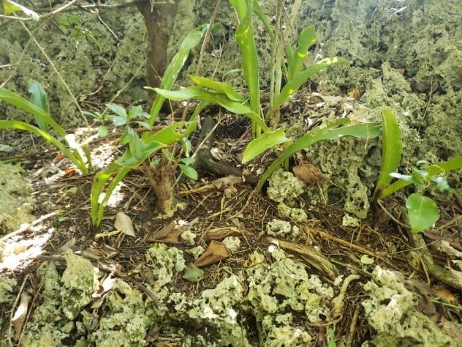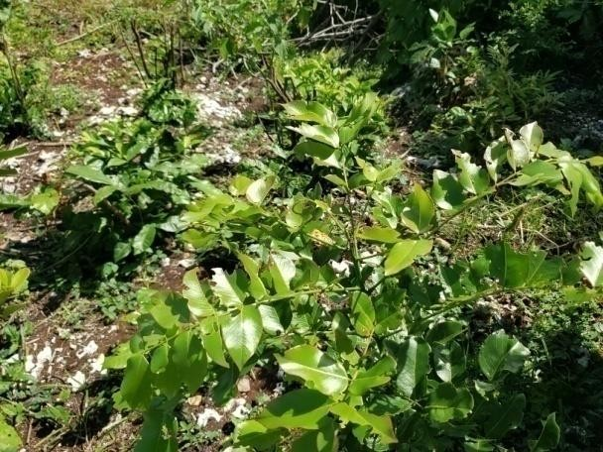

Photo (on up, UngujaUkuu) and Photo (on the down, Muungoni) show the nature of the land surface in most of the Menai Bay, 2023.

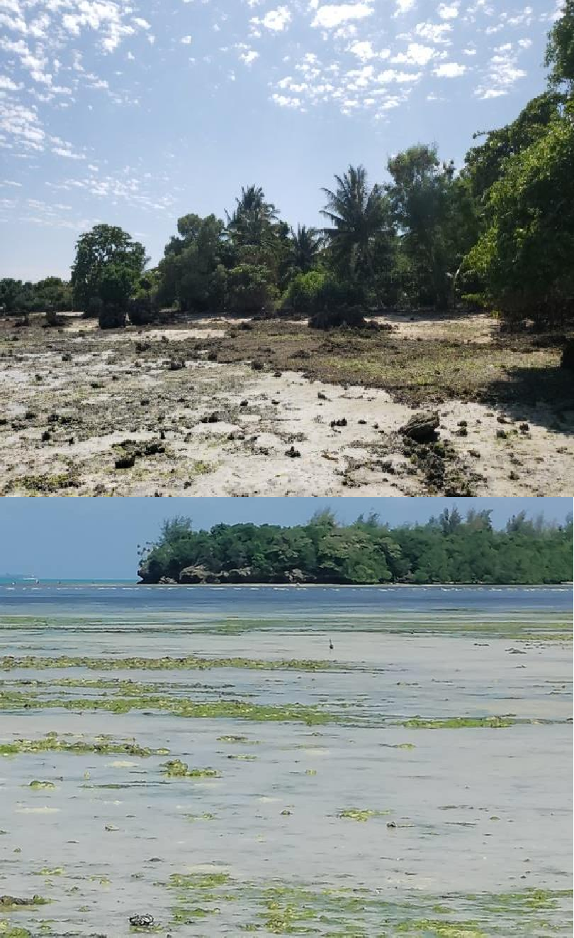
Photo (up) shows seashore surface from a brazed uneven coral outcrop and Photo (down)shows white sand seashore area free from braise coral. The photos were taken at UngujaUkuuKeapwani.

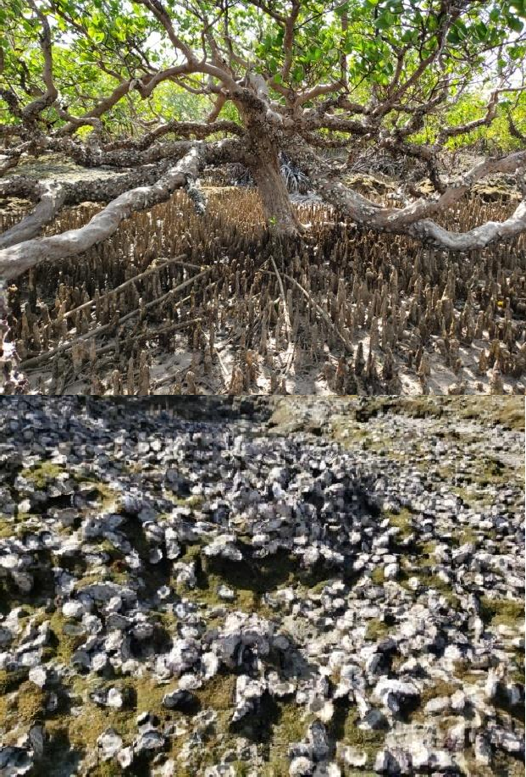
Photo shows one among mangroves plant sprout at seashore of Muungoni, Menai Bay, 2023 and Photo 8 shows a sort of colony of seashell on partially bruised corals at Muungoni seashore, 2023. Seashore and seawater area in triangle form, made by Uzi on one side and Muungoni and Unguja Ukuu on the other is predominant by mangroves including Rhizophora mucronata, Avicennia marina and Ceriopstagal, and 8 other species, which play a protective role of Menai Bay coastline. There are also a number sea grasses/weeds which spread in mass or small patches through the entire coastal line, Photo 9.
Seaweeds are found grow in small patches and some time found in settled form that indicates they came from other parts of the Bay.

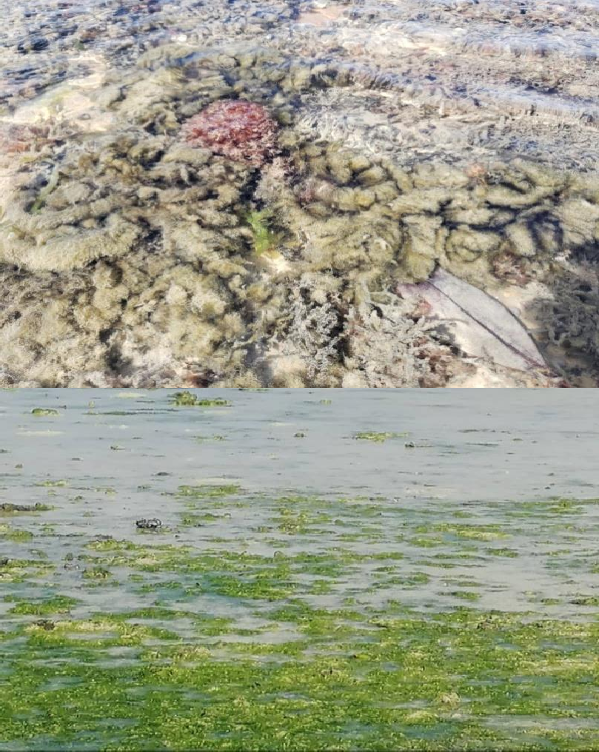

Photo (up) shows a mixture of sea grasses/weeds spread along Muungoni seashore, while Photo (down) shows a mass of seaweeds settled at Uzi seashore.
The Menai Bay accommodates a variety of fauna in its seashore and above (dry land) areas. However during the study walk on the area relatively small number of fauna was observed if compared to number in cited documents. This indicates that some of the fauna habitats in Menai Bay are migratory within a day time, seasons and particular area or environment. Again, during the study walk the team observed fauna which habitants on both dry and wet area are presented in Photo below, and those habitués in dry land. On the other hand, during the study walk there were few fauna species found on the dry land area. The team discussion considered that the observed inhabitants are migratory and commonly found in coral of Zanzibar.

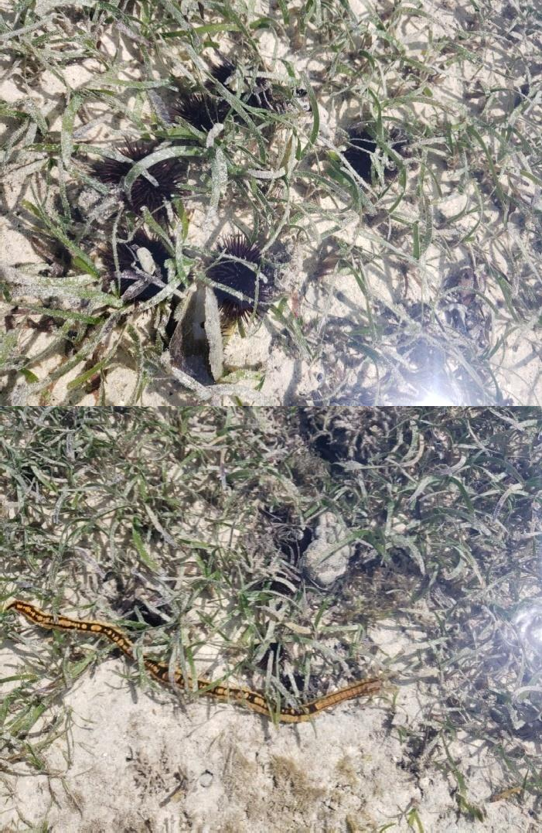

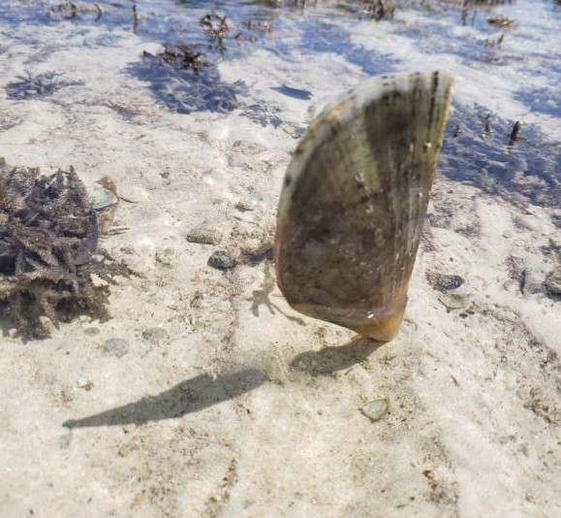

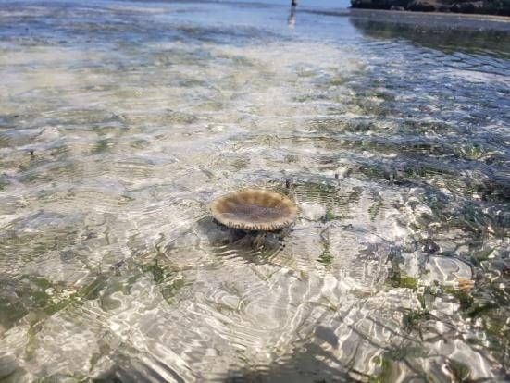

Top up to down are Photo showing the richness of fauna habitant in Menai Bay on seashore environment, 2023.

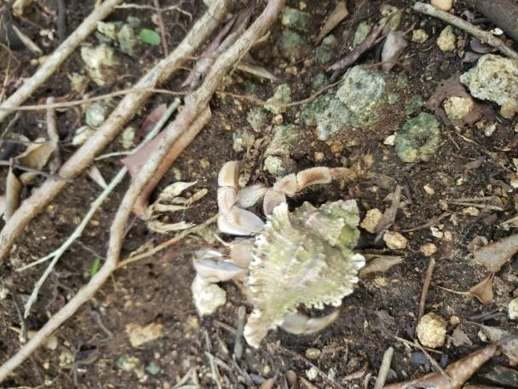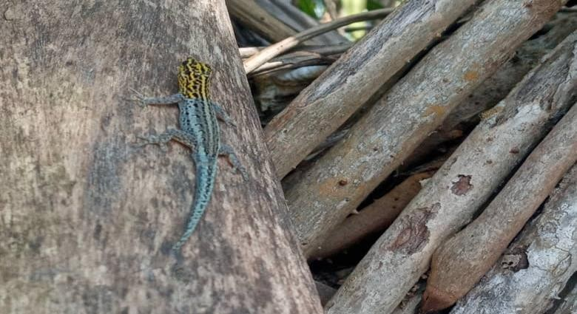
Photo (up and down) show fauna species habitant in between the wet and dry land.

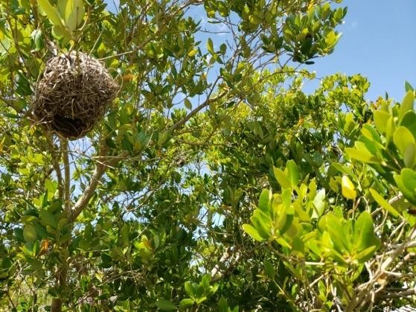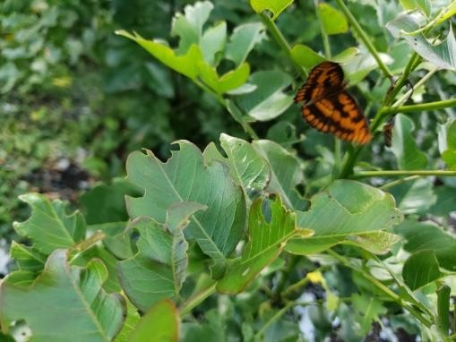

Photo (up) show some of the fauna and flora found in the area with less human activities found in coral seashore during the study walk, 2023

  - Summary of findings
This phase of fauna and flora resources inventory in Menai Bay Zanzibar has yielded the following findings:
    - Uzi Islet and its surroundings within Menai Bay is likely maintain its intactness on fauna and flora resources and can be used as among the hub for exploration and its contribution on knowledge, wildlife, culture, tourism, for social and economic gain of individuals, groups, family as well as the country as whole.

    - There were limited studies on fauna and flora resources conducted earlier on Menai Bay. And they are outdated and largely have been directed towards aspirations of foreign researchers. Hence, studies on fauna and flora resources need more effort to make the outcomes publishable national and internationally.
    - There is little involvement of local peoples in fauna and flora resources researches, but the local people are rich in knowledge of their environment, fauna and flora species, seasonal, migration and regeneration trends as well as horizontal or spatial distribution. So more collaboration with local people will upgrade studies on fauna and flora resources inventory in Menai Bay.
    - An increase of social and economic activities in Menai Bay area which pressuring the use of fauna and flora resources from the area have negative impact on the existence of relatively large number of fauna and flora resources in the near future if proper conservational measure not been implemented.
    - Menai Bay is an immediate host for a number of migratory birds and fishes. They do visit the area seasonally as hideout for regeneration or escaping from threatening weather condition, sea waves, and predators.
    - Honey production is decreasing dramatically due to the increase of poisonous effects from the application of pesticides in vegetable farms which are also encroaching towards the coastlines of the Menai Bay.
    - Pesticides reaching the seashore areas kill or harm fauna and flora resources in Menay Bay.
    - Corals caves and mangroves canopy are good reproduction zones for a number of fishes hibernate in shallow water within the Bay. However, there is ongoing destruction of these areas brought by mangrove cutting and unfriendly tourism activities.

    - The local peoples are ready to minimize the destruction of the resources in Menai Bay if they are empowered to engage themselves in other type of activities that will improve and stabilize their incomes.
    - The impact of climate change is knocking on the side areas surrounding the Menai Bay, although mangroves and coral outcrops spread across the area act as unique savor against the rapid changes of fauna and flora in the area.
    - The increase of settlements approaching the seashore is among factor influencing the decrease of fauna and flora resources in the Menai Bay.

5.0 CONCLUSION AND RECOMMENDATION
  - Conclusion
This phase of research on Menai Bay inventory of fauna and flora resources has come with the following conclusions:
    - The fauna and flora resources are relatively decreasing in diversity and number of species,
    - Some of fauna and flora resources such Jeta might enter on
endangered stage.
    - The level of biodiversity differs within the Menai Bay areas, whereby Uzi Islet is more likely been less affected zone.

Recommendation
Research team who conducted this phase of research on Menai Bay inventory of fauna and flora resources has come with the following recommendations:
    - Once the survey area covered by this phase of research was about 25 per cent, the results and conclusion are subjected to change as far as the research shall cover area of Menai Bay to its maximum. Therefore, the research shall be re-conducted.
    - The biodiversity inventory was done by observation but not to the extent of species identification, so it was recommended that the next phase of this research should involved species identification.

    - Different techniques will be used to sample different groups of animals in the study area. The techniques will differ in accordance with the species concerned. The techniques will enable to determine presence of species, their distribution and index of abundance. The sample will based on transects walks. The transect walk will located to cater for both habitat representation and spatial distribution.
    - The research so far undertaken has been varied in scope and includes taxonomic descriptions of species and their biogeography, behavior and ecology of single species, and studies of ecosystem processes. A number of monitoring programs are in place for wildlife, mainly through counts in and out of the study areas, and through monitoring individual populations during the course of long-term research.

6.0 REFERENCES

Department of Fisheries and Marine Resources. (2011). Guide to marine Conservation Areas in Zanzibar. Government of Zanzibar.

FAO, (2005). Global Forest Resources Assessment 2005: Thematic study on mangroves, Forest Resources Development Service. Rome: Italy.Retrieved from www.fao.org. Accessed on 25/ 09 /2014.

Finke J. (2006), Threats to Global Biodiversity. (http://www.global change: site Visited on 10th June, 2015).

Gall, J.P., Gall, M.D. and Borg, W.R. (2002), Applying education research.
APractical Guide. Fifth Edition. New York.

Kombo, Y. H (2010). Zanzibar Forest Biodiversity versus energy crisis and climate

Changes: Toward Zanzibar Environmental Policy Formulation. The Department of Commercial Crops, Fruits and Forestry.
Zanzibar.
Kupnick, G. (2001), Role of animal diversity. Centre for diversity of America. National Museum of Natural History.
Makame, (2006). Management plan for mangrove ecosystem of Jozani Chwaka Bay National park Zanzibar. Retrieved from www.dccff.com/archives/tp135
Malimbwi, R. E., Mugasha, A. G. &Monela, G.C. (2005), Reconnaissance Timber Inventory Report for Handeni Hill Forest Reserve in Handeni District,Tanzania. FOCONSULT, Faculty of Forestry and Nature Conservation, Sokoine University of Agriculture, Morogoro, Tanzania.
Ruitenbeek, H. Jack, H, &Ngoile, M. (2005). Blueprint 2050: sustaining the marine environment in mainland Tanzania and Zanzibar. World Bank Publications.
Silima, P. A., Jumah. S. M., Khamis. F. A., Hussein. I. H., & Othman. W. J. (2008).The inception report: The mangroves inventory, socio- economic survey and separation of general management plan of Zanzibar. Dept. of Forestry, Zanzibar.
Wildlife Division (1998) The Wildlife Policy of Tanzania. Ministry of Natural Resources and Tourism, Dar es Salaam, Tanzania.
Wilson, E. O. (1992) The Diversity of Life. Belknap Press, Cambridge, Massachussetts.WRI/IUCN/UNEP (1992) Global biodiversity strategy. WRI/IUCN/UNEP, Washington DC:Zar, J. H. (1996) Biostatistical Analysis 3rd edition. Prentice Hall, New Jersey.Tropical countries tend to have fewer Biases in biodiversity research PLOS ONE

