
ZANZIBAR AGRICULTURAL RESEARCH INSTITUTE
(ZARI)

RESEARCH TITLE

PERFORMING EVALUATION OF PROMISING CASSAVA GENOTYPES AT KIZIMBANI ZANZIBAR

2023/2024
Address: Kizimbani-Zanzibar
Email: Info@zarismz.go.tz

Authors: Salma Omar Mohammed, Ali Hamad Ali, Mushi.E and H.S. Juma

ABSTRACT
Cassava (Manihot esculenta Crantz) is a staple crop grown in over 90 countries, supporting the livelihoods of half a billion people in the developing world, particularly in Sub-Saharan Africa. It is vital both as a food security and for industrial processing due to its adaptability to diverse environments and tolerance to drought and acidic soils. This study addresses the need for developing high-yielding, Cassava Brown Streak Disease (CBSD)-resistant varieties to improve food security and economic stability in Zanzibar.The specific objectives include screening cassava genotypes for CBSD resistance and conducting participatory evaluations with farmers to understand their preferences for various cassava traits. The research was conducted at the Zanzibar Agricultural Research Institute (ZARI), Kizimbani, with trials planted during the long rains (Masika season) in April 2022 and repeated in April 2023. The study employed a Randomized Complete Block Design (RCBD) with two replications, each assigned 10 treatments of cassava varieties. Data collection included plant establishment, disease and pest tolerance, root yield. Key findings indicate that extended rainfall contributed to the good growth performance of the evaluated cassava genotypes. Mahonda and KBH2016B/521 exhibited the highest root yields, with 33.83 t/ha and
23.03 t/ha, respectively, while the local variety (Mtotoshoo) had the lowest yield (16.92 t/ha). The introduction of new CBSD-tolerant varieties significantly improved the cassava-growing system in Zanzibar. Disease incidence and severity were notably low across most genotypes, except for Mtotoshoo, which showed high CBSD incidence and severity. All evaluated genotypes demonstrated high harvest indices, indicating efficient conversion of photosynthates into economically valuable products.Farmers' participatory evaluations revealed a strong preference

for genotypes KBH2016B/316, MAHONDA, KBH2016B/3038, and KBH2016B/521 due to their high yield, disease tolerance, high dry matter content, and root shape suitable for selling.

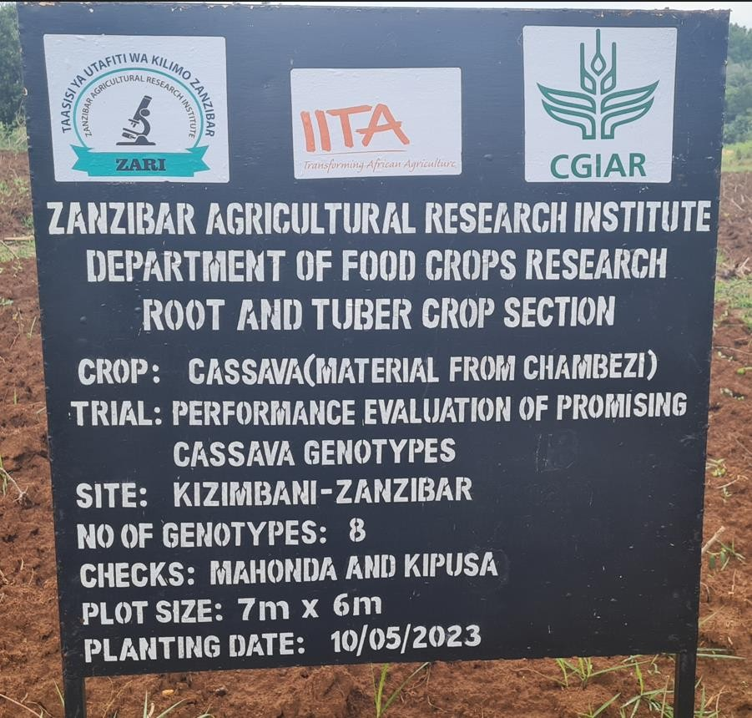
Photo 1: Cassava evaluation trial at Kizimbani, Zanzibar

10. INTRODUCTION
Cassava (Manihot esculenta Crantz) is a very important crop whereas grown in over 90 countries and support the livelihood for half a billion people in the developing world especially in the Sub Saharan Africa. It has been reported that, Cassava is an important source of food to many people in the tropics and sub-tropical locations. It plays significant role as a subsistence crop as well as its use in industrial processing (Ceballos et al., 2012). The importance of cassava is further emphasized by the fact that it is perceived as the future food security since adapted to a wide

range of environments, and tolerant to drought and acidic soils (Jarvis et al., 2012).
Tanzania is the fourth largest producer of cassava in Africa with an annual production of 5 million tons at a yield of 8 t/ha (FAOSTAT, 2014). In Zanzibar, cassava is second staple food after rice, and it is used as one of the strategic food crop due to its ability to sustain diverse weather conditions. Unlike rice, cassava can survive with just marginal rains and moisture conditions which made it to be grown even in the moisture stressed coral rag areas of both Islands of Unguja and Pemba.

The acquisition and selection of superior breeding material is a primary necessity in any breeding programme. Breeders constantly strive to develop improved genotypes that are superior not only in yield but also in a number of other agronomic and quality characteristics, over a relatively wide range of environmental conditions. The cassava plant is highly heterozygous making it difficult to identify parents with good breeding values. The flower is complete with both male and female parts. Cassava is propagated vegetatively through cuttings. This makes it possible to indefinitely perpetuate a good variety without changing its genetic make- up. Therefore, evaluation of varieties of cassava in replicated trials at several different locations and seasons give necessary information and useful agronomic traits for increasing cassava production.

PROBLEM STATEMENTS AND JUSTIFICATION
Cassava development and evaluation is very important aspect of crop improvement. However, due to several factors, including the genetic erosion caused by abiotic and biotic factors including disease infections have contributed to the reduction of the genetic resources variation. The occurrence of more aggressive virus strains of Cassava brown streak disease (CBSD) influence much the erosion of landrace plant resources. Thus, cassava virus diseases continue to cause widespread losses to cassava production throughout East Africa as well as Zanzibar (Alicai et al., 2007; Ndyetabulaet al., 2016). CBSD has been reported to reach up to 100% loss of crop plants particularly for the use of susceptible varieties under favorable condition. When cassava virus infect young

cassava plants, yields are reduced by up to 80% and 100% in the following seasons.
Despite the importance of the cassava improvement for disease and pest tolerance little work has been done on the improvement of CBSD resistance and determination of mode of inheritance of cassava genotype in Zanzibar. Therefore the development of new varieties are very important in plant breeding program which will help provide sufficient and valuable information that can assist in formulating efficient strategies for incorporation of resistant genes into high yielding and adapted lines of which will result the quick release of virus (CBSD) tolerant cassava as well as high yielding varieties. Therefore, the aim of this study is to identify varieties which are CBSD resistant and are high yielding because most communities of Zanzibar, grow traditional cassava varieties which are highly susceptible, as such address food insecurity and high poverty levels

Overall Objective
To increase food availability and income generation through developing improved cassava varieties in Zanzibar

Specific Objective
    - To screen cassava genotypes against CBSD diseases

    - Participatory evaluation with farmers’ attitudes or perceptions towards selected traits of cassava clones/varieties.

Specific Objective 1
To screen cassava genotypes against CBSD diseases
The trial was established at Zanzibar Agricultural Research Institute, Kizimbani. The trials were planted during long rains (Masika seasons) April 2022. The experiment was laid in a Randomized Complete Block Design (RCBD) with two replications. Each replication was assigned with 10 treatments of cassava varieties. Each plot contained three ridges of five plants per cassava genotypes at a spacing of one by one meter making the plot size of 15m². CBSD infected plants of highly susceptible genotype (Mtotoshoo) was used as a spreader to ensure that high CBSD pressure prevails in the evaluation plots. The genotypes involved under research are KBH2016B/521,

KBH2018/1171, KBH2016B/087, KBH2016B/316, MTOTOSHOO, KBH2016B/185, MAHONDA, KBH2016B/504, KBH2018/3038 and
KBH2016B/020. Three weeding operations have been done by using hand hoeing during all times of field trial.

MATERIALS AND METHODS
  - Location and duration
The trial was established at, Kizimbani agricultural research stations - Unguja. The trials were planted during long rains (Masika seasons) April 2022.and repeated in April 2023 to fast tract field evaluation and to have varieties that will go for release.

Materials
The experimental material were composed of eight genotypes and two check varieties as control. The genotypes were KBH2016B/521, KBH2018/1171, KBH2016B/087, KBH2016B/316, MTOTOSHOO, KBH2016B/185, MAHONDA, KBH2016B/504, KBH2018/3038 and
KBH2016B/020obtained from Zanzibar Agricultural Research Institute and International Institute of Tropical Agriculture (IITA).

Experimental design and treatment allocation
The trials adopted Randomized Complete Block Design (RCBD) with 2 replications. The replications were subdivided into subplots. Each sub plot contains three lines (ridges) of 5m long with the spacing of 1m x 0.3m.The plant spacing used was 1m x 1m within and between the rows including the guard rows. The plot size was 5m x3m equivalent to 15m². CBSD infected plants of highly susceptible genotype (Mtotoshoo) was used as a spreader to ensure that high CBSD pressure prevails in the evaluation plots.

Weather and Soil sample data collection
Rainfall (mm), temperature (degree Celsius) and relative humidity data were collected throughout experimental period. Soil samples from experimental sites were collected and analyzed at Soil Research Laboratory of the International Institute of Tropical Agriculture (IITA).
  - Growth variables, yield and yield components data collection Data collected were plant establishment, plant stand at harvest, disease and pest tolerance of the variety, number and weight of roots, Harvest

index and cassava dry matter. The harvesting and evaluation was done participatory at twelve (12) Months after Planting by ZARI scientists where individual farmers, farmer groups and local extension officers were invited for evaluation and assessment based on their criteria of selection.

Field monitoring and data collection
Field monitoring and data collection have been done once after planting. The gap filling was done 2 weeks after planting. The established genotypes were evaluated at one and three months after planting for plant establishment, CBSD foliar symptoms. CBSD root severity and incidence and CBSD root symptoms assessment were evaluated at 12 MAP based on the standard five point scoring scale for CBSD (Gondwe et al., 2003).Where a score of 1; meant no disease symptom while a score of 5; referred to the most severe infection. Scores of shoots and root CBSD symptoms was done based on the scale of 1-5 where; 1=no apparent necrosis, 2 = less than 5% of root necrosis, 3 = 5-10% of root necrosis, 4 = 10 - 25% of root necrosis, mild root constriction and 5
= >25% of root necrosis and severe root constriction.

Data analysis
Data on fresh root yield, CBSD scores were analyzed using SAS program (SAS, 2004). Least Significant Differences (LSD) test at 0.05 probability level was used for mean comparisons.

Specific objective 2
Participatory evaluation with farmers’ attitudes or perceptions towards selected traits of cassava genotypes/varieties.
During harvesting 15 farmers (3 women and 12 men) from potential cassava growing region Unguja were selected and invited to the trial field for participatory evaluation of preferable varieties. Also, 4 researchers and 2 extensionists participated in the evaluation. Farmers subjected to all the genotypes to a preference test and selected 4 genotypes, which combined high yielding, high dry matter and disease tolerance. However, in this study, farmers’ criteria for selecting genotypes were used in combination with measured, agronomic data.

The procedure for selection was described to the participants before each farmer started the selection exercise. Farmers were involved in the assessment of the growth and diseases attributes of the genotypes including appearance, CBSD, ACMD, root yield, drought tolerance by looking, and number of roots as well as stems by counting and general acceptability. Genotypes were assessed by using a subjective scale (1=very poor, 2=poor, 3=moderate, 4=good and 5=excellent). By the use of matrix ranking procedure mean scores were ranked. Farmer opinions on individual clones were computed into frequencies. Scores of the clones were compared using means. However, in this study, farmers’ criteria for selecting genotypes were used in combination with measured, agronomic data by researchers and hence farmers were subjected to all the genotypes to a preference test
Results of the farmer’s responses to the harvested genotypes (Table 2) indicated that; KBH2016B/316, MAHONDA,KBH2016B/3038 and KBH2016B/521 were preferred according to good yield performance, disease tolerance, high dry matter and good shape of the roots for selling. KBH2016B/316 and KBH2016B/3038 are yellow fleshed varieties with better carotene. Some of the reasons for disliking certain genotypes were roots being fibrous and low dry matter. However, some of the rest genotypes may not have been good in yield instead tolerant to virus diseases, could be acceptable for other uses such as flour and value added products, and this should be considered in future studies.

KEY RESULTS

    - Generally, the crop indicated to have a good growth performance due to extended rainfall. Based on root yield, variety Mahonda and genotype KBH2016B/521 scored highest value (33.83t/ha) and (23.03t/ha) respectively, whereas local variety (Mtotoshoo) scored lowest yield (16.92 t/ha). Therefore, the introduction of new varieties that are tolerant to Cassava Brown Streak Disease; made greater contributions in the cassava growing system in Zanzibar.

    - Most of genotypes indicated to have low disease infection scoring except for local variety (Mtotoshoo) showed high CBSD incidence (36.26) and (3) severity disease symptoms and genotype KBH2016B/521incidence (1.25) and (3) severity disease symptoms.

    - Harvest index (HI) is a good indicator of the potential performance of a genotype. Harvest Index (HI) is the ratio of Total Root Weight (TRW) to the Total Biological Yield (TRW + foliage yield). All ten (10) genotypes had harvest indices over 50% -80% (Table 1) which is very high according to the CIAT classification (Kawano, 1990). High harvest index is of great importance for improving economic yields because high harvest index of cassava indicates that storage roots constitute the main sink for photosynthesis, thus genotypes with more of this partitioning are desirable. A genotype with a high HI indicates that it is more efficient at converting photosynthesized products into an economically valuable product.
    - The evaluated cassava genotypes have been accepted by many farmers following their participation in the harvesting. In addition to that, genotypes, KBH2016B/316, MAHONDA,KBH2016B/3038 and KBH2016B/521 were most preferred by farmers (85%)

    - Integration the farmers’ preference with combined score and the selection index based on the agronomic data, assisted in the final identification of the best genotypes developed in the evaluation.

Table 1. Mean performance of 10 genotypes on yield and CBSD incidence and severity in 2022/2023.

SN | Genotype name | Plants harvested | Harvest Index | Total Fresh Root  Yield | Root Number Incidence | Root Number Severity
1 | KBH2016B/521 | 14 | 0.68 | 23.02564 | 1.25 | 3
2 | KBH2018/1171 | 14 | 0.57 | 17.14286 | 0 | 1
3 | KBH2016B/087 | 12.5 | 0.82 | 20.44872 | 0 | 1
4 | KBH2016B/316 | 12 | 0.75 | 21.57143 | 0 | 1
5 | MTOTO SHOO | 10 | 0.65 | 16.92308 | 36.26 | 3
6 | KBH2016B/185 | 10.5 | 0.75 | 22.41667 | 0 | 1
7 | MAHONDA | 13.5 | 0.6 | 33.83333 | 0 | 1
8 | KBH2016B/504 | 14 | 0.64 | 21.30769 | 0 | 1
9 | KBH2018/3038 | 11.5 | 0.75 | 19.88636 | 0 | 1
10  Mean | KBH2016B/020 | 12  12.4 | 0.63  0.684 | 22.08333  21.86391 | 0  3.751 | 1  1.4

Table 2: Pair wise ranking of 10 genotypes for farmers.
Genotype | 1 | 2 | 3 | 4 | 5 | 6 | 7 | 8 | 9 | 10 | Score | Rank
KBH2016B/316 |  | 1 | 1 | 1 | 1 | 1 | 1 | 1 | 1 | 1 | 9 | 1
KBH2016B/087 |  |  | 3 | 2 | 2 | 2 | 7 | 8 | 2 | 10 | 4 | 6
MTOTOSHOO |  |  |  | 3 | 3 | 3 | 7 | 8 | 3 | 10 | 5 | 5
KBH2018/1171 |  |  |  |  | 4 | 4 | 7 | 8 | 4 | 10 | 3 | 7
KBH2016B/185 |  |  |  |  |  | 6 | 7 | 8 | 5 | 10 | 1 | 9
KBH2016B/020 |  |  |  |  |  |  | 7 | 8 | 6 | 10 | 2 | 8
MAHONDA KBH2016B/521 KBH2016B/504  KBH2016B/3038 |  |  |  |  |  |  |  | 7 | 7  8 | 7  10  10 | 8  6  0  7 | 2  4  10  3

RECOMMENDATIONS.
    - Farmers can increase productivity and incomes through the introduction of new improved varieties.
    - Farmers’ opinions and knowledge systematically collected and used in selection decisions
    - Involving farmers in selection helped to identify high yielding and disease tolerance genotypes that could/should ultimately accelerate their adoption.

ACKNOWLEDGEMENT
    - IITA - Tanzania for providing support and giving suggestions and guideline in conducting the research
    - Ministry of Agriculture Livestock and Natural Resources for allowing us to use the facilities and support during the implementation of the trial at the Zanzibar Agricultural Research Institute (ZARI)
- Also the Management of Zanzibar Agricultural research Institute is highly appreciated for the administrative support provided and enabling environment for conducting research. The support included the provision of land for the trials and experiments, for provision of office space and but also for allowing its staff to participate fully in the running of the experiment
- IITA for germplasm and information exchange.
- We would also like to appreciate the cooperation and support we received from the participating farmers and extensions during the assessment and evaluation of the genotypes

6.0 REFERENCES

Alicai, T., C.A. Omongo, M.N. Maruthi, R.J. Hillocks and Y. Baguma et al., 2007. Re-emergence of cassava brown streak disease in Uganda. Plant Dis., 91: 24-29.

Ceballos, P. Kulakow, C. Hershey Cassava Breeding: Current Status, Bottlenecks and the Potential of Biotechnology Tools Trop. Plant Biol., 5 (2012), pp. 73-87.
Donald, G.M.J., 2010. Virus ravages cassava plants in Africa. The New York Times, Published http://www.nytimes.com/2010/06/01/science/01cassava.html . Gondwe, F.M.T., N.M. Mahungu, R.J. Hillocks, M.D. Raya and
C.C. Moyo et al., 2003. Economic losses experienced by small-scale farmers in Malawi due to cassava brown streak virus. Proceedings National Code on Renewable Natural Resources and Environmental Protection, October 20-30, 2002, Mombasa,
Jeremiah, I.L. Ndyetabula, G.S. Mkamilo, S. Haji, M.M. Muhanna, C. Chuwa, S. Kasele, H. Bouwmeester, J.N. Ijumba, J.P. Legg The dynamics and environmental influence on interactions between cassava brown streak virus disease and the whitefly, Bemisia tabaci Phytopathol., 105 (2015), pp. 646-655
Kanju, E., Saleh, H., Mohamed, S., Masumba, E., and Mtunda, K(2013). On-station performance of cassava brown streak disease tolerant varieties in Zanzibar.
Kawano K (1990). Harvest index and evolution of major food crop cultivars in the tropics. Euphytica, 46: 195-202.
M.N. Maruthi, R.J. Hillocks, K. Mtunda, M.D. Raya, M. Muhanna, H. Kiozia, A.R. Rekha, J. Colvin, J.M. Thresh Transmission of Cassava brown streak virus by Bemisia tabaci (Gennadius) 10/8/2020
Ndyetabula, I.L., Merumba, S.M., Jeremiah, S.C., Kasele, S., Mkamilo, G.S., Kagimbo, F.M. & Legg, J. (2016). Analysis of interactions between cassava brown streak disease symptom types facilitates the determination of varietal responses and yield losses. Plant Disease, 100(7), 1388-1396.

